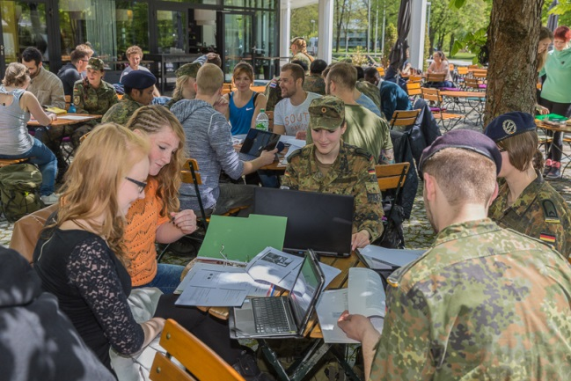
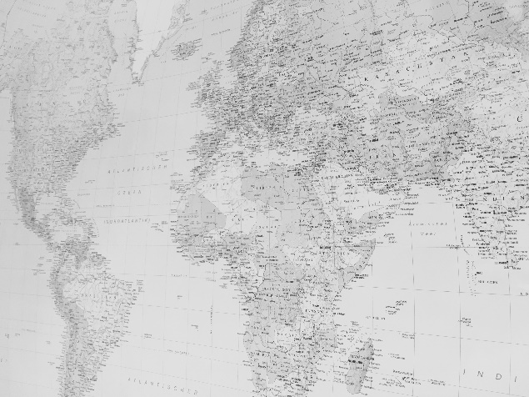
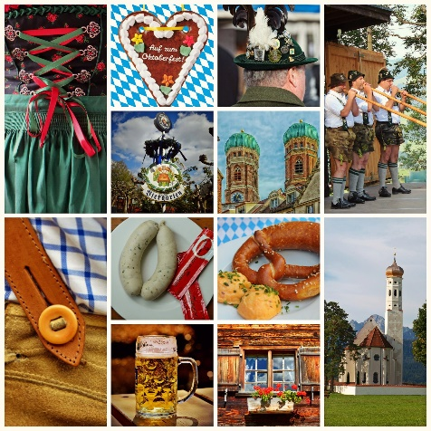
Fact Sheet for Traineeship / Research at Universität der Bundeswehr München (UniBw M)
Important Information at a glance:

Application at UniBw Munich for an Erasmus+ Traineeship, a Bachelor’s or Master’s thesis or Research for your doctoral thesis
Please send the requested documents by e-Mail (in pdf format, no hard copy is needed) to the International Office, Incoming Mobility Coordinator: lucia.celinkovic@unibw.de

- completed registration form (please download from our website: https://www.unibw.de/internationales-en/inbound/downloads/downloads)
- A one-page abstract of the research focus of your bachelor's, master's or doctoral thesis:
This one-page abstract is very important in order to be able to find a suitable professor in one of our many departments who is willing to academically supervise your bachelor's, master's or doctoral thesis.
The exposé is not needed for ERASMUS+ traineeships!
- Transcript of Records
- curriculum vitae
- a copy of your passport
- university enrolment certificate
- filled in form “Confirmation of Insurance” (please download from our website: https://bit.ly/2w1vTCA)

Application Deadlines
The timeframe of your traineeship, Bachelor’s or Master’s thesis is not bound to the trimester dates as you will not be participating in courses and exams at our university.

Please send me your application documents by email at least 2-3 months before your expected arrival.

Be prepared
- Please read the “UniBw Munich brochure” and leaflet “About Us” available under “Downloads” on our website.
- Please bring one passport photograph with you. It is needed for your sports card on campus.
- Make sure to always have enough cash euros on you: in Germany we use a lot of cash and it is sometimes the only possible way of payment in local stores or restaurants that do not accept credit cards. Also, payment on campus (such as for meals) is in cash only.

Who’s who?

Head of the International Office (IO):
Dr. Alexandra Bettag
alexandra.bettag@unibw.de

Incoming Mobility Coordinator:
Lucia Celinkovic, M.A.
lucia.celinkovic@unibw.de

Outgoing Mobility Coordinator:
N.N.
international.office@unibw.de

Telephones:
Head of the Office: 0049 89 6004 4683
Inbound Students: 0049 89 6004 4682
Outbound Students: 0049 89 6004 2524

Postal Address:
Universität der Bundeswehr München
International Office – Auslandsbüro
Werner-Heisenberg-Weg 39
85579 München

Useful Links

International Office Website:
https://www.unibw.de/internationales-en

Incoming Students:
https://www.unibw.de/internationales-en/inbound

Application information:
https://www.unibw.de/internationales-en/inbound/exchange-students/exchange-students

Buddy Program:
https://www.unibw.de/internationales-en/buddy-program

Accommodation:
https://www.unibw.de/internationales-en/inbound/accommodation

Downloads:
https://www.unibw.de/internationales-en/inbound/downloads/downloads

The Universität der Bundeswehr München
The Universität der Bundeswehr München (UniBw M) was founded in 1973 in order to provide academic training for officers and officer candidates. Today there are around 3,500 registered students, including 575 women, approximately 30 international officers and 290 civilian students.
The University offers a diverse range of studies in two domains: University and University of Applied Sciences. The trimester system, short distances on campus and individual support in small groups allow students to complete their academic studies successfully in a relatively short time. The intensive study environment forms the ground on which a bachelor’s degree and a consecutive master’s degree can be earned in a period of four years. The academic degrees are equivalent to those at the state universities. Teaching and research are conducted independently. Excellent scientific facilities enable internationally competitive research at a high level.

The main task of UniBw M is to provide officers and officer candidates of the Bundeswehr (= Federal Armed Forces) with a university education. Officers in the German Armed Forces are committed to military service for at least 13 years. This includes studies at our university, after first passing the assessment center process in Cologne.
But the university is also open to civilian students: via an industrial scholarship or via bilateral university agreements.
On the basis of bilateral cooperation agreements, it is possible for civilians from foreign countries to complete a portion of their studies at UniBw M. Currently, we offer foreign students the opportunity to stay for up to 12 months.

Connections around the globe
UniBw M is globally networked. It has partnerships with more than 70 internationally renowned universities and institutes in Europe, the USA and Latin America. In cooperation with the International Office on campus, students can participate in a variety of exchange programs without having to pay tuition fees. Around eight percent of the student population and researchers come from abroad.

More on our website: https://www.unibw.de/internationales-en

Degree Programs and Courses in English
Potential recruits have a choice of 16 bachelor's and 15 master's degree programs. Studying in small groups allows individual support: on average the professor-student ratio is only 1 to 18. Because of this range of academic and personal training based on critical thinking and scientific research as in civilian universities, graduates can pursue careers not only in the military, but also in the private sector or public service after leaving the German Armed Forces. All of the university’s degrees are state-recognized and accredited. The courses are adapted regularly to reflect current developments in the economy, society and research.

UniBw M is made up of the University and the University of Applied Sciences:
https://www.unibw.de/internationales-en/inbound/degree-programs/degree-programs

Academic Calendar
In contrast to other universities, the standard period of study at UniBw M is only 3 years for a bachelor’s degree and one additional year of intensive study for a Master’s degree. Each academic year is structured into the trimesters, not semesters:

Fall Trimester: October – December
Winter Trimester: January – March
Spring Trimester: April – June
Lecture-free time: July - September

Campus Life
Located on the 14-hectar grounds of a former military airbase on the outskirts of Munich, the campus university combines studying with research and work. Despite the size of the campus, students can get from the lecture halls to the main facilities on campus and to the cafeteria in a matter of minutes.

University library, computer center, media center, and language training center:
https://www.unibw.de/internationales-en/inbound/campus-life

Sports
Sports are a top priority on campus and its facilities, which include a climbing wall, a swimming pool with a sauna and steam bath, a fitness center, different sports classes, tennis and beach volleyball courts and a ski and snowboard rental, are open to everyone on campus.
https://www.unibw.de/hochschulsport/sportzentrum

Extra fees
Printing costs for printing in our computer center: around 5 Cent for black & white copy and 15 Cents for color printing.
There are various other printers in other locations different from the computer center. Please check out the prices here: https://bit.ly/2Y6ml4X
Meals on Campus:
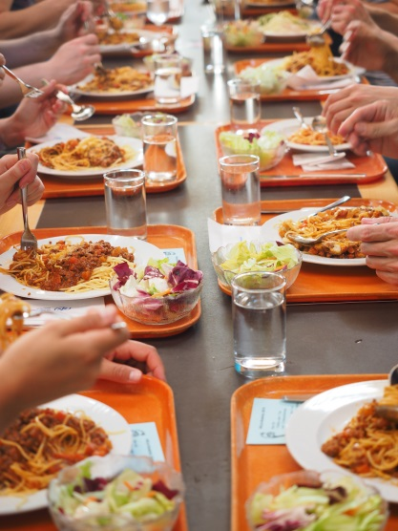
There are several places to eat at the university:

Mensa | Cafeteria
Building 30
The least expensive option is the university cafeteria (Mensa), which serves reasonably priced breakfast, lunch, and dinner from Monday through Friday. The cafeteria is closed on weekends.

Opening hours:
Breakfast: Mon-Fri: 6.30 - 8.15 am
Lunch: Mon-Fri: 10.45 - 1.30 pm
Dinner: Mon-Thu: 4 – 6 pm

The monthly meal plan is available for download on their website: https://www.unibw.de/campusleben/verpflegung/mensa

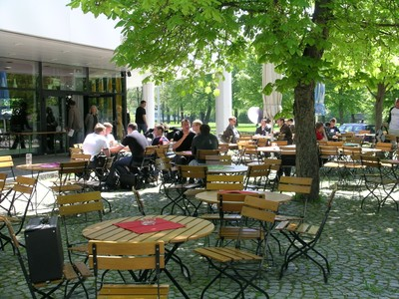
Restaurant "Brandl"
Building 30
There is also a restaurant on campus. At “Brandl” you can choose from a selection of entrées at lunch and dinner time; also snacks and drinks are served all day.
In the evening, the restaurant offers a good selection of pizzas and a delivery service on campus:

Opening hours:
Mon – Fri: 8 am – 22 pm
Fri: 8 am – 2 pm

https://www.unibw.de/brandl

Uni Bar
Building 30

Opening hours:

Tuesday – Thursday: 7 pm – 2 am

Friday: 8 pm – 2 am

https://www.unibw.de/brandl/unibar

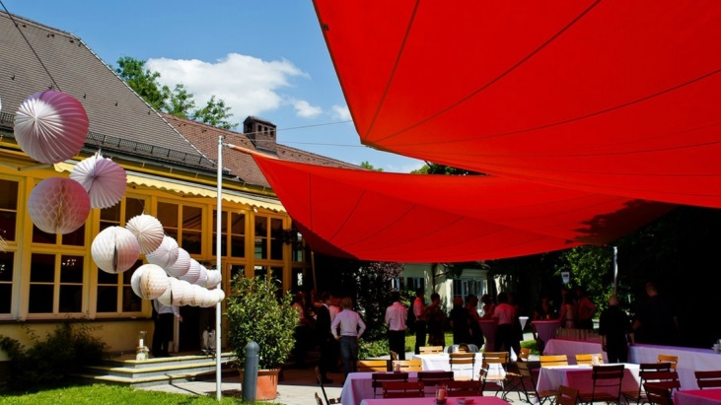
Officer's Club | UniCasino
Building 61
The UniCasino is not a casino, but a restaurant on campus in building 61 that offers a selection of dishes from Monday through Friday at lunch and dinner time and also hosts students' parties and festive events throughout the year.
Opening hours:
Monday - Thursday: 11 am – 2:30 pm and 5 pm – 10 pm
https://unicasino.weebly.com/

Legal requirements – Before Arrival
Entry requirements and visa
US citizens and students from EU/EEA states and some other countries may stay in Germany without a visa for three months. Do you need an entry visa? Please see https://www.auswaertiges-amt.de/en/visa-service/-/231148.

In case an entry visa is requested, you will need an official invitation letter issued by the International Office or your inviting professor at UniBw M. Contact us!

Get information regarding the German statutory health insurance (for further information please see below).

Legal requirements – After Arrival
Register your address
After entering Germany and planning to stay for more than three months, you must register your address in Munich at one of the residence registration offices operated by the Department of Public Order within two weeks. For more information, see the section on “Registration of Residency”:
https://www.muenchen.de/rathaus/home_en/Department-of-Public-Order/Registration-Deregistration.

The Foreigners Office at the Department of Public Order here in Munich is responsible for issuing and renewing residence permits. You must apply for this permit while your visa/ allowance to stay is still valid (normally within 90 days after arrival):

- Filled in application form (completed in full)
- A valid passport
- A recent photograph that satisfies biometric criteria (photo booths are available at the Foreigners Office)
- Enrolment Certificate from UniBw M
- Proof of adequate funding (e.g. a formal obligation by a third party)
- Proof of adequate health insurance

For more information on the residence permit, please see here: https://stadt.muenchen.de/infos/new-foreign-students.html.

Health Insurance
In Germany, all students are obliged to take out a valid health and nursing care insurance policy.
- As a European citizen, you can apply for your European Health Insurance Card (EHIC) with your local health insurer.
- Besides, The "German Academic Exchange Service" offers an affordable combined health, accident and liability insurance package (costs are around 140,00 EUR per month): https://bit.ly/3yhh1d4
- The private health insurance policy “mawista”’ is also a good option:
(Student Classic plus package, around 40,00 EUR per month): https://bit.ly/1TL2oHx

For further information please see “Health and Nursing Care Insurance” https://www.unibw.de/internationales-en/inbound/exchange-students/exchange-students.

To Dos at UniBw M – After Arrival
Before, during and after your arrival, the international office can assist you with the following tasks:

- Finding a UniBw M professor as academic supervisor for your Bachelor’s or Master’s thesis or your traineeship
- Health insurance
- Accommodation or links to the Munich Student Union
- Buddy Program
- Campus access card (for access to our campus through all gates): A deposit of EUR 20 is required for the card. Please have the amount ready in cash (cash only), as the deposit has to be paid in our payment office on campus. You will receive a receipt for the deposit. The deposit will be returned to you at the end of your stay in exchange for your access card
- Wi-fi access on campus
- Printing and scanning in our computer center
- Library
- Sports facilities
- University cafeteria (called “Mensa”)
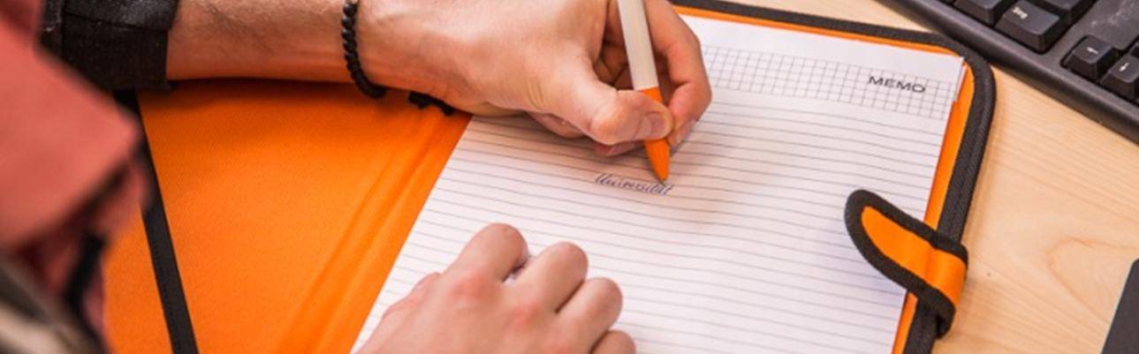

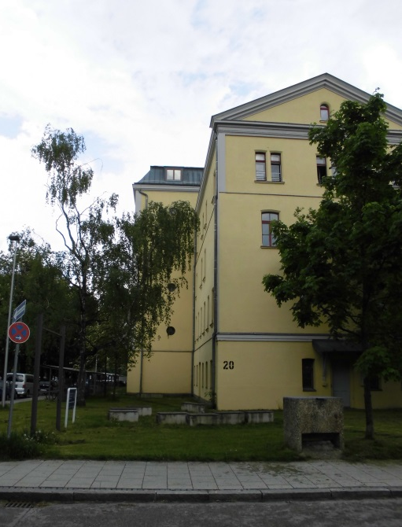
Student Apartment
It is possible to apply for a room or bed in a shared double bedroom (depending on availability) in a military building belonging to the Bundeswehr Career Service in Munich City Center. Since the apartment is located in the very center of Munich, grocery stores and laundry service stores as well as a big park (the Olympic Park Munich) and public transportation services are in close proximity. It takes about 50 min. by public transportation to get from the accommodation to our university campus which is located in the outskirts of Munich.

The apartment is on the 5th floor of the building, there is no elevator. It offers space for up to 9 international students. All rooms are fully furnished (bed, cupboard, desk, desk lamp, shelf, chair, etc.). Pillow, blanket, bed linen and two small towels are provided. You might want to bring a large towel with you or buy one in Munich. There is a shared kitchen in the apartment. Cooking utensils, pots and pans are available, as well as spoons, forks and knives. Shared showers and restrooms divided by sex are available on the 4th floor.

The apartment does not provide a dishwasher, a washing machine, nor a dryer. Laundromats are available in the vicinity of the accommodation.

An internet connection is not available in the building and cannot be set up. Students can receive wi-fi on their smartphones by purchasing a German prepaid SIM card. You can go online on your laptop by buying an Internet modem stick and by regularly charging the stick with credit.

Overnight guests staying for a few nights need to be registered two weeks in advance (ask the International Office how to register your guests) and there is a fee to be paid per guest and per night.

The accommodation building belongs to the Bundeswehr (= The German Armed Forces) Career Center. Since they house young military applicants in the building on the 1st, 2nd, and 3rd floor overnight, it is very important to respect the night’s peace from 22 pm – 6 am and to help keep the facility clean.

Cleaning Services are provided once a week (floors, hallways, sanitary facilities, and kitchen floor), but only the floors, no surface cleaning.

The apartment in Munich City Center does not have a reception to welcome new students. Without your keys, you will not be able to enter the accommodation building. Please stay in close contact with the International Office about your arrival, so we can arrange your check-in and the hand-over of keys with our Housing Office on our university campus thus making your arrival as smooth as possible.

The address of the accommodation is:

Bundeswehr Karrierezentrum
Hedwig-Dransfeld-Allee 7
80637 Munich

If you want to stay in the student apartment, please send me your signed and filled in Housing Application Form by email at least four weeks before your arrival. Your application for accommodation is not valid without the signed Housing Application Form sent to me by email in due time. Because accommodation is limited, your application for accommodation is no guarantee for a reservation in the apartment.

Other options:

Rooms in Shared Flats
Another option is to find accommodation by contacting the Private Accommodation Service of the Munich Student Union. This Private Accommodation Service passes on the details of several hundred private rooms to students on offer by private landlords: https://bit.ly/3oofGiF

Rental platform HousingAnywhere
Rental platform for mid- to long-term rental solutions in Munich:
https://housinganywhere.com/s/Munich--Germany
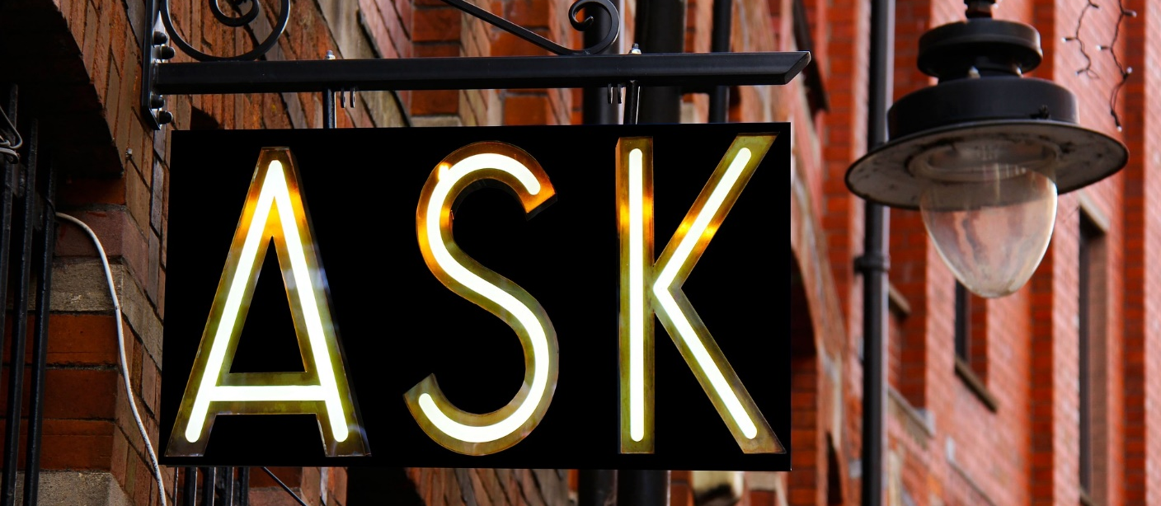
The City of Munich

Munich is the capital and most populous city of the German state of Bavaria. With a population of approx. 1,5 million inhabitants as of 31 July 2020 it is the third-largest city in Germany, after Berlin and Hamburg, and thus the largest which does not constitute its own state, as well as the 11th-largest city in the European Union. Munich is a very cosmopolitan city, with foreign nationals accounting for almost 25 percent of its population. Over 100 consular representations and a large number of international business clubs and cultural societies foster dialogue between Munich, Bavaria and various countries.

You will have many questions about daily life, leisure activities and many more. The following pages and links are meant to help you give you a good idea about every aspect of life in Munich.

Official Website of the City of Munich: http://www.muenchen.de/int/en.html

Welcome! New to Munich: http://www.muenchen.de/int/en/living/new-to-munich.html

Munich Drinking Water: https://www.swm.de/english/m-wasser.html

Munich Public Transportation: https://www.mvv-muenchen.de/en/index.html

Average living costs for students studying in Munich: https://bit.ly/2UOoeDQ
